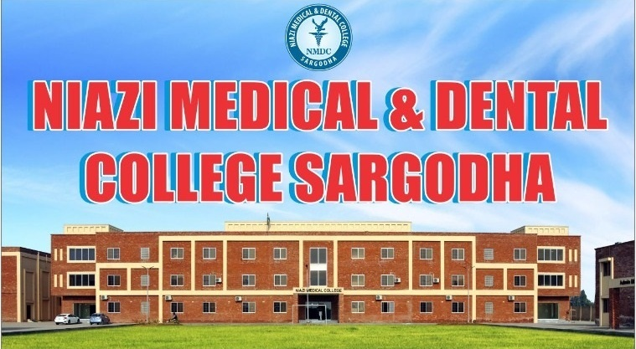

**Niazi Medical and Dental College is pleased to announce admissions to MBBS session 2020-2021.**

Candidates listed in the PMC portal under NMDC are requested to visit college administration office with their original documents and parents' income tax returns from 25-1-2021 to 30-1-2021 (Sunday admission office will be open ).

***Only those students will be considered for final admission who will confirm documentation process until 30.1.2021 by visiting Admin Niazi Medical and Dental College Sargodha.***

Merit list will be displayed on college website after 30th January 2021

